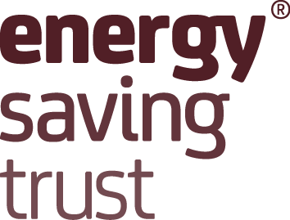
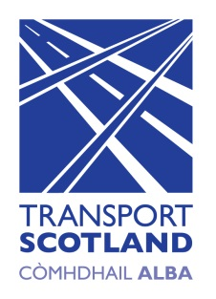

STATEMENT OF COMPLIANCE
WITH CONDITIONS OF GRANT

The European Regional Development Fund (ERDF), Low Carbon Travel and Transport (LCTT) Challenge Fund.

[Name of project and reference number]

This is to confirm that the Grant claimed by [name of Grantee] in relation to the above Project during the financial year ended [date] was properly due and was used for its intended purpose(s) in accordance with the terms and conditions of the Grant. This statement is supported by the records of [name of Grantee] and signed by the company’s Director of Finance or equivalent.

Signed:

Name in block capitals:

Position:

Date:

